**Distribution of Species Richness Across Different Habitat Types**

**Tabitha Jew,** Aleya Peji, Angela Pagano, Rebecca Aung

**I. Abstract**

As human activity expands, interactions between wildlife and humans increase. To see if the human alteration of land results in a decrease in wildlife species, data has been gathered on parks and their respective wildlife conditions. Cameras were set up in parks in the Denver Metro area to observe the wildlife in parks. The data found supported the hypothesis that human alteration of land is having a negative impact on wildlife species. These findings suggest that it is important for conservation efforts to be made, because it would benefit the survival of wildlife species.

**II. Introduction**

Rates of urbanization are increasing and interactions between wildlife in urban areas and humans are increasing because of it (Soulsbury 2016). The Urban Wildlife Information Network is a project that is taking place in a growing number of cities in the country. These cities collect data on wildlife species by setting up cameras in areas around the city in order to observe wildlife patterns. The increasing rates of urbanization, which is the expansion of human activity, into wildlife habitats, is the largest cause of biodiversity loss (Wang 2017). But because there are so many aspects to urbanization such as pollution, road systems, and noise levels, it is difficult to pinpoint exactly what aspects of urbanization is affecting wildlife species. As human populations grow, there will be an increasing need to understand how to plan the growth of cities so that all species living in the city can benefit. The UWIN project’s goal is to do more research on urban wildlife ecology to obtain more information that can be used to educate future efforts for wildlife conservation. It is important to maintain biodiversity, which is the variety of species in an environment. Biodiversity is important to the survival of all species because each species has a function or niche in its environment (Lefcheck 2015).

Since there are many aspects that make up urbanization, choosing a specific aspect of urbanization will help in collecting information on whether that variable potentially has an effect of wildlife species. The specific research for this study is focused on determining if habitat type has an effect on the species richness in the Denver Metro area. The independent variable in this study is the habitat type, while the dependent variable is the species richness. Species richness is the number of different species in a habitat. A habitat is the environment that a species inhabits. For this research, there were three categories for habitat types which include artificial, mixed, and natural. These habitat types each have parameters that allow for the identification of the habitat. Artificial habitat types have high maintenance, high landscaping, and do not have any naturally occurring plants. Mixed habitat types have a mix of some maintenance, some landscaping, and a few naturally occurring plants in the area. Natural habitat types have no maintenance or management and have many naturally occurring plants. This research question will allow for insight on what habitat types wildlife species may prefer over the other types. This will show what species may be able to flourish in certain urbanized areas.

**III. Methods**

The study area for this research is in Denver, Colorado. A transect was chosen in this area so that it would represent a gradient from rural to urban areas. The transect runs through downtown Denver, which has high urbanization. There are many road, lots of noise, and many buildings. Towards the west, the transect enters Golden, which is more rural. Then, the transect enters Aurora towards the east. Using this transect, parks were then chosen for camera placement for this study.

Site Selection

The photos of the wildlife species will be collected by cameras set up along the transect in the Denver Metro area. Parks were chosen from within 5-kilometer sections of the transect. Within each of these 5 kilometer transects, there were five parks chosen. There was a total of 40 parks chosen for camera placement, and these parks were within two kilometers of the transect, while simultaneously being at least one kilometer away from another park. Choosing the parks with this method allows the data collected to well represent the entire transect. Once the park locations were decided, the land owners of the parks were contacted for permissions to conduct the study in the parks. This study had a total of 35 park locations selected.

Camera Deployment

The cameras that were placed at each of the selected parks are Spartan cameras. They are motion activated cameras that are strapped to trees at each of the selected parks. These cameras take a picture every 30 seconds when it senses movement. The camera is directed at a Fatty Acid Scent tablet located about 3-5 meters away The FAS tablet will be secured to a tree and will be used to attract wildlife species towards the camera location. The cameras are in their locations for four weeks of each season of the year.

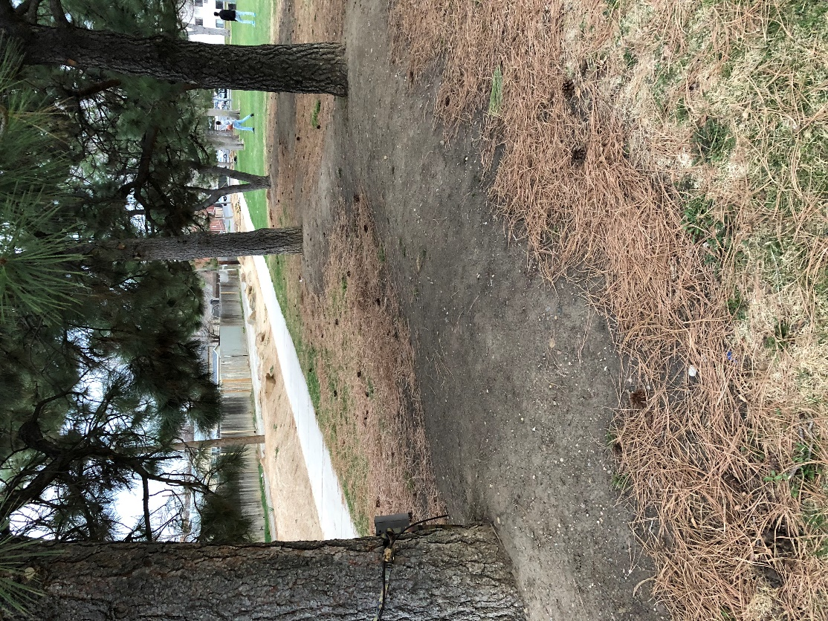

Figure 1. Camera Set-up at Park Locations. Camera is strapped to a tree pointed towards the FAS tablet, which is attached roughly 3-5 meters across from the camera.

Data Collection

The photos that the cameras take will be tagged by students in the class. They will be tagged in the Microsoft Access program, which will allow for easy access of information such as species type spotted, number of animals spotted, and location of the photo taken. For this research, the variables that will be analyzed will be species richness and habitat type. The habitat type is the independent variable, and the species richness is the dependent variable. The habitat type is defined by the categories artificial, mixed, and natural. These are determined by the amount of maintenance a park receives, as well as if the park has naturally occurring plants. The species richness will be measured by analyzing the photos and determining how many different species appeared at each of the park locations. Domestic mammals and birds are not included in the species richness count. The resulting number will be the resulting species richness of a location.

Data Analysis

To analyze the data, graphical summaries will be used. The graphical summaries will be analyzed by looking for any distinguishable pattern in the graphs. For this data, a box and whiskers graph will be used to show the relationship between habitat type and species richness. The box and whiskers graph will also allow the different categories for habitat type to be displayed. A bar graph will also be used to show graphically the distribution of habitat types among all the park locations. This will show how many of each habitat type there was in the sample, in comparison with each other.

**VI. Results**

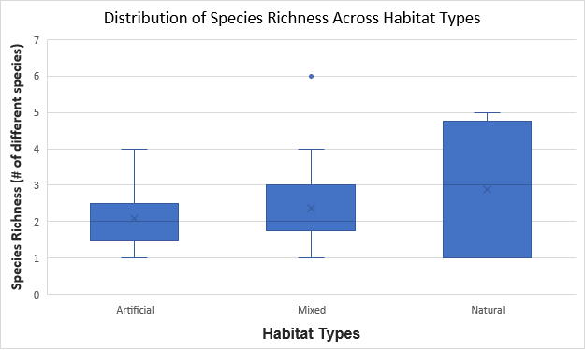

Figure 2. Distribution of Species Richness Across Habitat Types. Data used was gathered from 35 park locations. Species richness was determined by the number of different species seen at each habitat type. Domestic mammals and birds were not included in the species richness counts. Five number summary - Artificial: **Min**: 1, **Q1**: 1.5, **Med**: 2, **Q3**: 2.5, **Max**: 4. Mixed: **Min**: 1, **Q1**: 2, **Med**: 2, **Q3**: 3, **Max**: 6. Natural: **Min**: 1, **Q1**: 1, **Med**: 3, **Q3**: 4.5, **Max**: 5.

The distribution of species richness is higher in the natural habitat type as seen in Figure 2. This is to be expected as there are less urbanization aspects in parks with a natural habitat. The average species richness of the artificial habitats is 2.07 different species per park. The average species richness of the mixed habitats is 2.36 different species per park. Natural habitats had the highest average species richness, which is 2.89 different species per park. While graphically there seems to be a trend, the averages are quite close. Figure 2 also shows that there was a species richness of six in the mixed habitat type, which is an outlier. The species richness of 6 is the highest species richness observed out of all the park locations. Artificial and mixed habitat types both had the same median species richness among the park locations, while natural habitats have a median of 3 species richness.

Figure 3. Distribution of Habitat Types Among Park Locations. The number of each park type is shown graphically. Each bar represents a category of habitat type and the number of parks that fell under that category. There were a similar number of artificial and mixed habitat types in the park samples. There were much fewer natural parks in the sample compared to artificial and mixed types.

Our sample size included 35 park locations. Of the 35 park locations, 13 parks were artificial, 14 were mixed, and 8 were natural. Figure 3 shows the lack of natural habitats in the sample size in comparison to the other habitat types.

**V. Discussion**

The results of this study point towards urbanization resulting in a loss of biodiversity. They suggest that the more humans alter the wildlife environment, the less species richness is observed. Although the sample of parks was small and only eight of them were natural type habitats, there still seemed to be a trend in the data. This information could be useful because it gives further evidence that planning future building projects or construction will be important for maintaining biodiversity.

The average species diversity for each habitat type increased from artificial to mixed and from mixed to artificial (Figure 2). This suggests that as the habitat becomes more natural, there is more species diversity. The more man-made an environment is, the more urbanized the area. Urbanization is correlated with lower species diversity and richness (Wang 2017).

While there is a trend that seems to exist, the mixed habitat category had an outlier of a species diversity of 6 (Figure 2). This point represented Gates Crescent Park. There were 13 other mixed habitat parks besides Gates Crescent Park (Figure 3). These other parks were used to determine why Gates Crescent had such a greater species diversity. After analyzing the other attributes of mixed parks, it was found that Gates Crescent had a much closer water source in comparison to the other mixed park locations. This may be a potential factor in why there is an outlier in Figure 2.

Also, as seen in Figure 3, there were not many natural park habitats in the sample size. This may have affected the results and graphical summaries. In the future, a larger sample size of parks with a greater addition of natural habitat parks may show more conclusive evidence that the more natural a habitat, the higher the species richness will be. It could also be beneficial to have more than one camera at each location, since some parks are bigger than others. As a result, a single camera may not fully represent the animal richness of a location.

Another potential issue that may have influenced the results is the understanding of the classifications between artificial, mixed, and natural habitats. Since many different students went to collect data on parks, there may have been different parameters used to distinguish between habitat types. This would cause the results to be inaccurate and unrepresentative of the park locations.

Future research for this topic could include a tighter, more specific parameter for the definitions of habitat types. Also, a larger sample size of park locations would help make the data more representative of reality. Repeating this study with these factors could give more insight on whether habitat types affect the species richness.

References

Lefcheck, J. S., Byrnes, J. E., Isbell, F., Gamfeldt, L., Griffin, J. N., Eisenhauer, N., ... & Duffy,

J. E. (2015). Biodiversity enhances ecosystem multifunctionality across trophic levels and habitats. *Nature communications*, *6*, 6936.

Soulsbury, C. D., & White, P. C. (2016). Human–wildlife interactions in urban areas: a review of

conflicts, benefits and opportunities. *Wildlife Research*, *42*(7), 541-553.

Wang, J. et all. (2017). Building biodiversity: drivers of bird and butterfly diversity on tropical

urban roof gardens. *Ecospher*e, 8(9).